AM000-Asia-China-Han-32 Inscriptions-Eight Arc-Four Bat-Four Kneeling Shamans

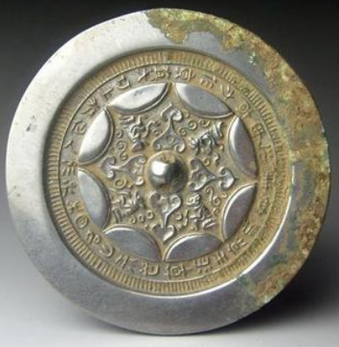

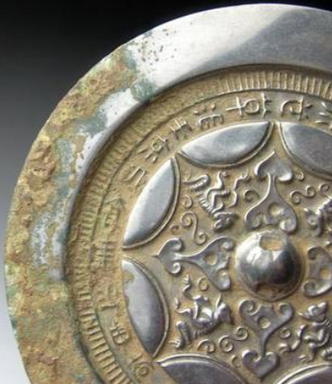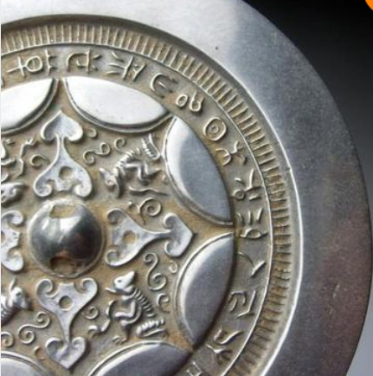

# Han Dynasty semicircle grass auspicious inscriptions bronze mirror 5in